
MUUGLines
The Manitoba UNIX User Group Newsletter
Volume 29 No. 3, November 2016 Editor: Wyatt Zacharias
Next Meeting: November 8, 2015

Daemon-Dash and Presentation:
For this month’s Daemon-Dash, Paul Sierks will present nginx, a high-performance web server using a modular event-driven architecture.

The presentation this month will feature guest presenter Neil Thomson, from Powerland Computers. Neil is a senior solution architect at Powerland, and will be presenting some of the latest technology announced by HP and Intel.


Watch MUUG Online
Missed a meeting, or want to follow along with a demo at home? Video recordings of the Daemon-Dash and presentations are now available on the MUUG website and on our YouTube channel.

https://muug.ca/meetings/video

https://www.youtube.com/channel/UCOhDmKEXk9oUJActy_u4cUA
Creative Commons License

Except where otherwise noted, all content in this newsletter is licensed under a Creative Commons “Attribution-ShareAlike 2.5 Canada” License.
http://creativecommons.org/licenses/by-sa/2.5/ca/deed.en_CA
Where to Find the Meeting

Interim location: U of W, Room 1M28
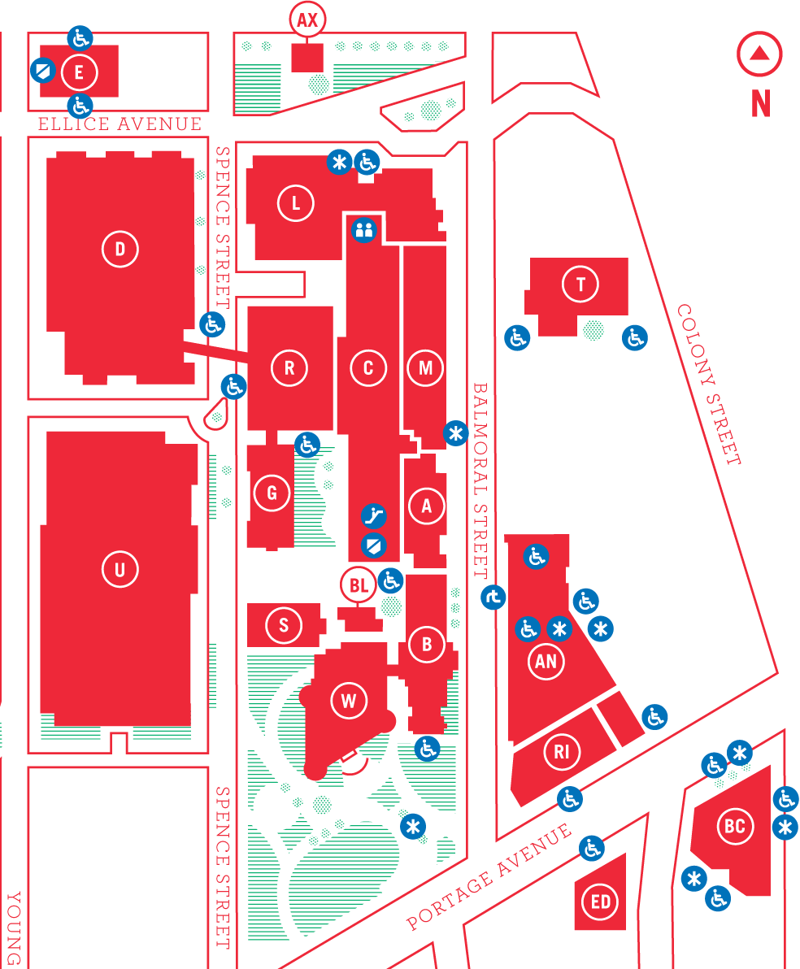
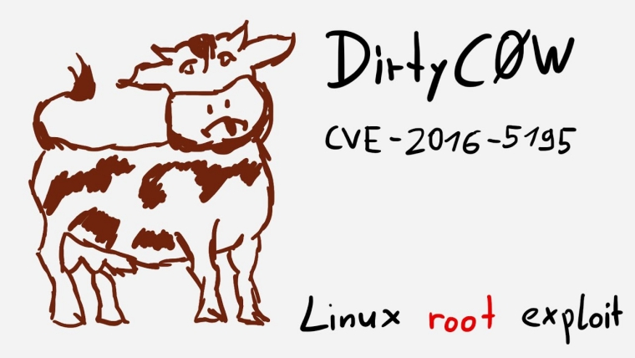
Meetings are held in the University of Winnipeg’s Manitoba Hall (marked “M” on the map), along Balmoral Street south of Ellice Avenue. We can be found in room 1M28 this year, but may occasionally get relocated to nearby rooms. If there is a change, it should be conveyed via a sign on the door to 1M28 (and 1L08, too). Parking is available on the surrounding streets.
Please see http://www.uwinnipeg.ca/maps for further information about parking and access to the campus.

The latest meeting details are always at:

https://www.muug.mb.ca/meetings/
2016-2017 MUUG Board Elections
Adam Thompson, 2016-2017 MUUG Board Election
Nomination Committee
Every November, the group holds its Annual General Meeting. The main goals of the meeting are to elect the new board, and to pass any special resolutions, if required. The Board may consist of up to nine (9) people.
As of this writing, the following nine members are allowing their names to stand for (re)election.

Trevor Cordes: Owner, Tecnopolis Enterprises
Trevor Cordes (B.Sc. CompSci) has owned and operated Tecnopolis Enterprises, a computer VAR, programming and consultancy company, since 1999. Linux and FOSS have been the keystone of Tecnopolis since inception, embodied in their flagship do-everything appliances for small business. Trevor was President of the Atari ST User’s Group for four years, between 1995-1999. He prefers Fedora and Perl.

Gilbert Detillieux: Systems Analyst, University of Manitoba
Gilbert Detillieux has been working with UNIX as a programmer, system administrator, and trainer since 1980. He worked as a computer consultant specializing in UNIX, from 1983 to 1989, and is currently working as a Systems Analyst for the University of Manitoba’s Department of Computer Science, where’s he’s worked since 1989, installing, supporting and upgrading the department’s network and UNIX server infrastructure. He was co-founder and past president of the Technical UNIX User Group (now MUUG), and has been an active member of the MUUG board ever since.

Kevin McGregor: Systems Specialist, City of Winnipeg
Kevin McGregor provides server, platform and infrastructure support in the City of Winnipeg’s Information Systems Department. After having briefly used UTS on an Amdahl mainframe in university in the mid-80s, he dabbled in Coherent and then converted to Linux and OpenBSD. He has been a member of MUUG since the early 90s, edited the group’s newsletter for a number of years, presented various topics at MUUG meetings and has served on the board for the majority of his membership.

Katherine Scrupa: LAN Administrator, Steinbach Credit Union
Katherine Scrupa is a LAN Administrator at SCU. Katherine has been a member of MUUG since 2006, during which she has been using Linux at home. Her educational pursuits in Computer Science led her to a Network Technology CCNA (Hons.) program at Red River College in 2010, with an emphasis on networking and system administration.

Paul Sierks: Priceline Partner Networks
Paul Sierks is a software developer and system administrator currently employed by Priceline Partner Networks. He was previously employed by Quipped Interactive Learning Technologies in the same field. Many of you will know him from his enthusiasm for Arch Linux, including his presentation on that.

Adam Thompson: Senior Systems Administrator, Avant Systems Group
Adam first unknowingly used UNIX in 1988, while playing NetHack on the QNX BBS in Ottawa, which gave him a huge advantage the first time he encountered vi(1)! He first ran into UNIX professionally in 1990, and started using Linux in 1991. Adam is the author of several termcap(5) and terminfo(5) entries, deployed the first cross-platform, public, networked instant-messaging system in Manitoba, and installed the first UnixWare system in Manitoba. He has developed several UNIX/Linux courses, and has also taught RDBMS administration. Adam has been a member of MUUG since 1995, and a board member for over a decade. Adam currently attempts to make multiple versions of Linux, Windows, Solaris and BSD all play together nicely, in between working on customer installations of Atlassian software and making virtualization environments do his bidding.

Tyhr Trubiak: Systems Administrator, Thorkelson Consulting
Tyhr Trubiak is a Systems Administrator at Thorkelson Consulting, supporting a mixture of linux and Windows.
Tyhr holds a B.Sc. (CompSci) from the University of Manitoba.
His interests include acting, 2D node-based digital compositing (visual effects for movies) and anything Jeep related.

Brad Vokey: Owner, Fortresss Software
Brad is the owner of Fortress Software Inc. and the creator of the Matchmaker Fundraiser (aka “Matchomatics” - a fundraiser that provides compatibility lists for millions of students across Canada and the US). Brad started the company in 1985 using Apple ][ computers and 6502 machine language. Then switched to 68000 machine language on Atari ST computers in 1986 and then to C on Atari TT030 computers soon after. The original C program and Atari TT030 computers are still very much alive and in use to this day! In 2004, Brad started using Linux on Tecnopolis servers, and joined MUUG in 2006. He previously served on the board of the Atari ST Users Group (STUG) and became a board member of MUUG in 2011. He has been keeping our finances in order as your MUUG treasurer since 2013.

Wyatt Zacharias: UNIX/Linux Administrator, Manitoba Blue Cross
Wyatt Zacharias is the UNIX/Linux and newly Network administrator at Manitoba Blue Cross. He manages a mix of RedHat Linux, HP-UX, and SuSE Enterprise installations. Wyatt has been president of MUUG for the previous two years, and served as vice-president the year before that. Wyatt graduated from Red-River college in 2014, and is a RedHat certified engineer.
CVE-2016-5195: Dirty Cow
On October 19th it was announced that a new local privilege escalation vulnerability was found in the Linux kernel, affecting all versions since 2.5.22 (released 2007). The vulnerability is caused by a race condition in the Linux memory subsystem that handles copy-on-write breakage of private read-only memory mappings. Unprivileged users are able to exploit this flaw to gain access to otherwise read-only memory mappings and perform changes to increase system privileges.
According to Phil Oester, the researcher that found the bug, they have already witnessed the exploit being used in the wild. Although the vulnerability is only exploitable with local access, other vulnerabilities such as SQL injection or misconfigured CGI can allow an attacker to run the exploit remotely.

https://goo.gl/e3TKva
DynDNS Goes Offline from Massive DDoS Attack
Starting at 11:10UTC on Oct. 21 DynDNS announced they were monitoring and mitigating a DDoS attack causing increased resolution latency on customers’ domains. At 15:10UTC the intensity of the attack increased, and began causing resolution failures for DynDNS customer domains. Sites affected included Twitter, the Playstation Network, and Github.
The attack in total consisted of three waves of attack, the last of which ended at 22:17UTC Oct 21. After the attack it was reported by CNBC that the U.S. Department of Homeland Security would be investigating the source of the attack.
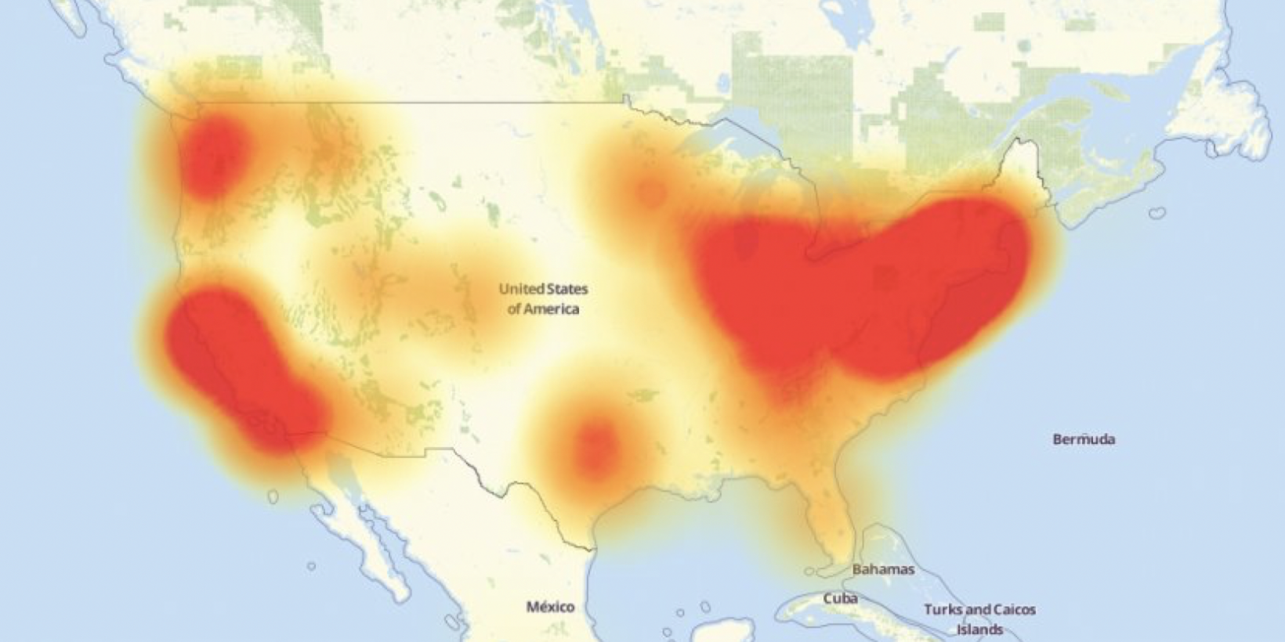
Level3 heatmap of outages across the United States
https://goo.gl/y4s2p4
Yahoo Said to Provide Full Cooperation in Assisting NSA With Email Scanning
According to undisclosed sources from within the company, last year Yahoo Inc secretly built a custom piece of software designed to scan all incoming emails for information provided by U.S. Intelligence officials.
Under a classified U.S. government order, Yahoo was forced to provide the means to scan millions of accounts. It is unknown what data was collected from the scanned accounts, or what the intended purpose of the scanning was.
According to former employees, Yahoo CEO Marissa Mayer’s decision to willingly comply with the order roiled some senior executives and is said to be the reason for the 2015 departure of Yahoo Chief Information Security Officer Alex Stamos.
To make matters worse and to limit disclosure, Yahoo’s security team was not informed on the development or operation of the new scanning software. When initially discovered, Yahoo’s internal security teams believed that unknown hackers had broken into the systems.
https://goo.gl/9VnTlO
Apple iOS 10 and OSX Vulnerable to Remote Code Execution in JPEG Images
Just released by Apple, iOS 10.1 patches 12 CVE vulnerabilities, including a remote code execution vulnerability in its handling of JPEG images.
Additionally Apple released macOS Sierra (10.12.1) which contains patches to 16 CVE vulnerabilities, including the same JPEG vulnerability found in iOS.
https://goo.gl/vvZukt
Sponsor Thank-You

Les.net (1996) Inc.
Continued thanks go to Leslie Bester of Les.net (1996) Inc. for providing rack space, power, and dual 10Gbps, dual-stack (IPv4 & IPv6) network connections for the new MUUG server.
We now have 21TB of mirrored data online here in Manitoba, with plenty of room to grow. It turns out it’s harder than you’d think to fill up 40TB while staying within our mandate...
Book & User Group Discounts

O’Reilly
We’ve had reports that the O’Reilly group discount code no longer works. Please let us know if that is or isn’t the case.

No Starch Press
No Starch Press has established a discount for user group members. It’s valid for 30% off everything they publish, and it doesn’t expire. Use “MUUG” as the discount code when ordering from their website.

Les.net
Les.net (1996) Inc., a local provider of VoIP, Internet and Hosting services, has offered to provide a 10% discount on services to MUUG members. Contact sales@les.net by email or or +1 (204) 480-3382 by phone for details.
MUUG has gone social!
For better or worse, you can now find (& follow!) MUUG on some social platforms. Get interactive and share all about MUUG on social media.

 twitter.com/manitobaunix

 facebook.com/ManitobaUnix

 www.linkedin.com/grps/MUUG-Manitoba-UNIX-Users-Group-1102007

 meetup.com/Manitoba-UNIX-User-Group

