
MUUGLines
The Manitoba UNIX User Group Newsletter
Volume 37 No. 8, April 2025 Co-Editors: Trevor E Cordes & Bradford C Vokey
Next Meeting: April 1st, 2025 7:30pm
We continue to meet on the first Tuesday of every month - no fooling this month!
In Person and Online

Main Presentation:
Programming With Closures
Unknown by many programmers, closures and first-class functions enable some pretty cool programming techniques that can make your code more maintainable.
In a short presentation, Trevor Cordes will demonstrate what they are, how to use them, and explain why they can be desirable.

RTFM: the return of /bin Diving!
Everyone in attendance will be encouraged to help Brad Vokey bumble about on the command line to figure out how to use a random /bin program.

In person attendees are treated to coffee, tea, pop, and cookies. Parking is free, copious, safe, and just a handful of feet from the door.
We encourage all members to attend in person. However, if you cannot attend in person, please watch and interact with the meeting online and partake of our professional grade camera, microphone and dedicated stream moderator.
To attend via the internet:
Check and refresh muug.ca/meet after 7:00 pm on April 1st. There is no need to create an account in Big Blue Button, nor login. Just enter a name as your screen name and hit join.
https://muug.ca/meet
Where to Find the In Person Meeting
Fortress Software Inc
350 Keewatin St – Unit #2
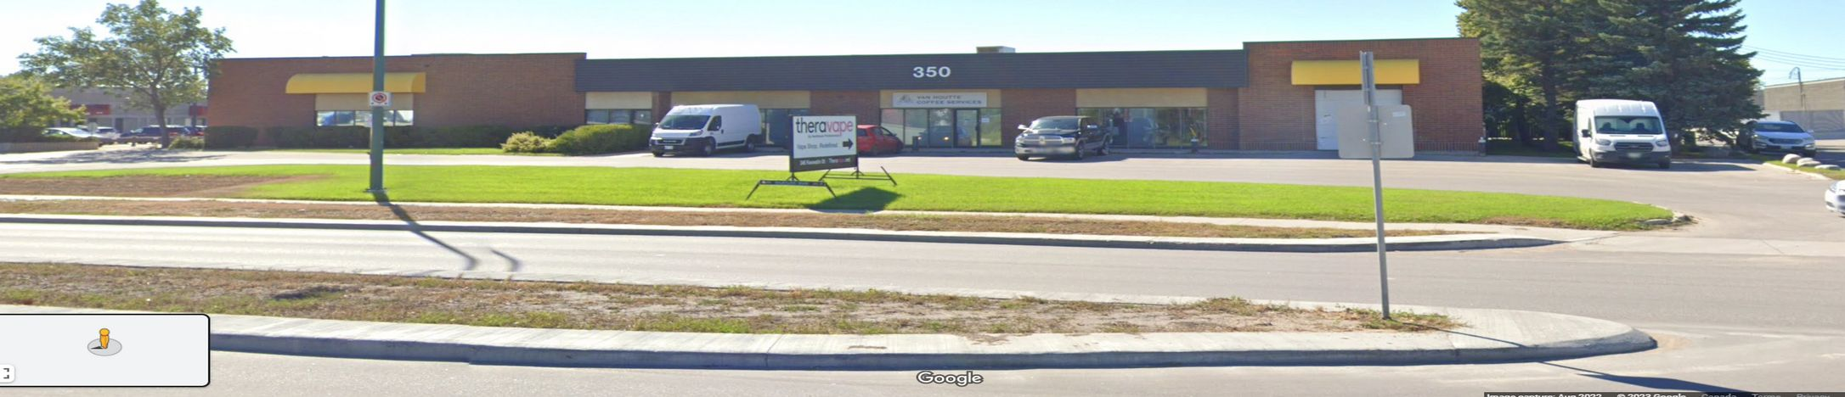
Doors will be open at 7:00 pm with the meeting starting at 7:30 pm.
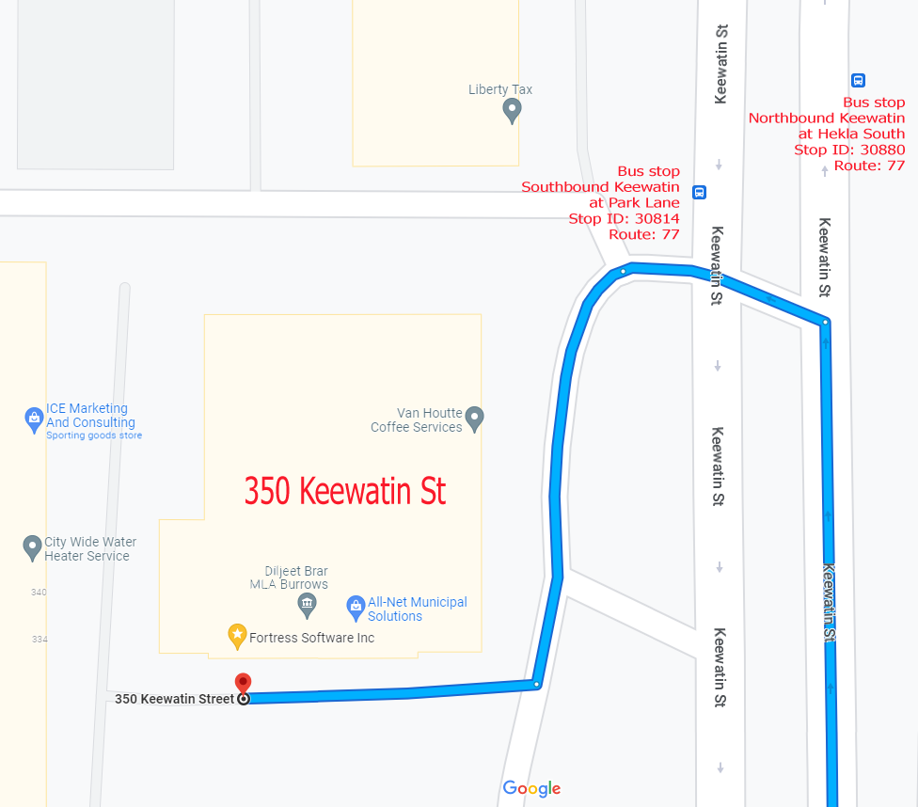
If driving, enter the parking lot using the most north-eastern entrance (far right in the top picture) and drive around to the south west corner of the building (the blue route in the map detail on the right).
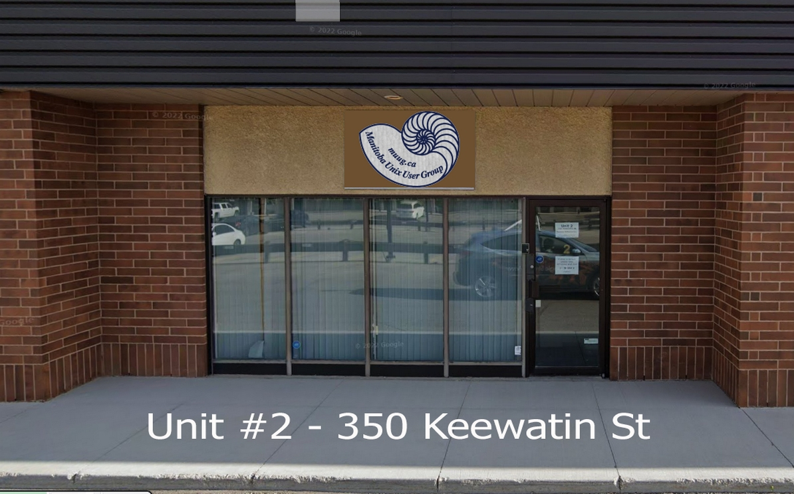
You can park in any of the free, ample, and safe parking spots that say “reserved” in front of units #1 through #4 before entering into unit #2.
Bus stops #30814 and #30880 (route 77) are only 150 meters away. The last bus leaves for Polo Park at 10:15 pm and for Garden City at 10:31 pm.
Logan Ave. bus routes #19, #26, and #27 are a 600 meter (8 minute) walk to the south.
The latest meeting details are always at:

https://muug.ca/meetings/
April Door Prize(s)

Every month MUUG gives away a couple of tech themed e-books, a couple of *NIX-themed stickers, and some months we even have physical paper books and magazines to give away!
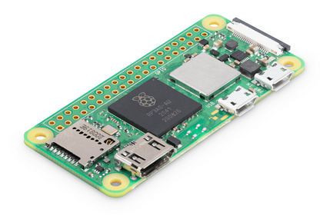
This month we have one more Pi Zero W2 (with a Pi SD card) to give away!
Everyone is encouraged to enter the door prize draw, both in-person and virtual attendees. You don’t have to be a member to enter, but members have exclusive access to the first draw. Members also get the privilege of not having to be present (physically or virtually) for the draw in order to claim their prize.
Needsrestart From Library Updates?
by Trevor E Cordes
When updating the MUUG server from Debian 10 to 12, this author came across a wonderful aspect of Debian that is lacking in the Red Hat/Fedora world: Debian’s updater system would tell you which daemons needed to be restarted if dependent libraries were updated! How cool is that?
The Fedora world will update critical libraries, even with security updates, and merrily ignore the daemons that are using them. Thus allowing you to continue running without a restart, say, apache, after, say, libssl is updated. Thus leaving you completely vulnerable when you think you’re fully patched. Yay.
Never fear: a solution is here! The needsrestart package aims to fill the void. Its rpm description is:
needrestart checks which daemons need to be restarted after library upgrades. It is inspired by checkrestart from the debian-goodies package
Now that’s something every RH/Fedora server user can get behind!

https://github.com/liske/needrestart

Connect your phone to your desktop with KDE Connect
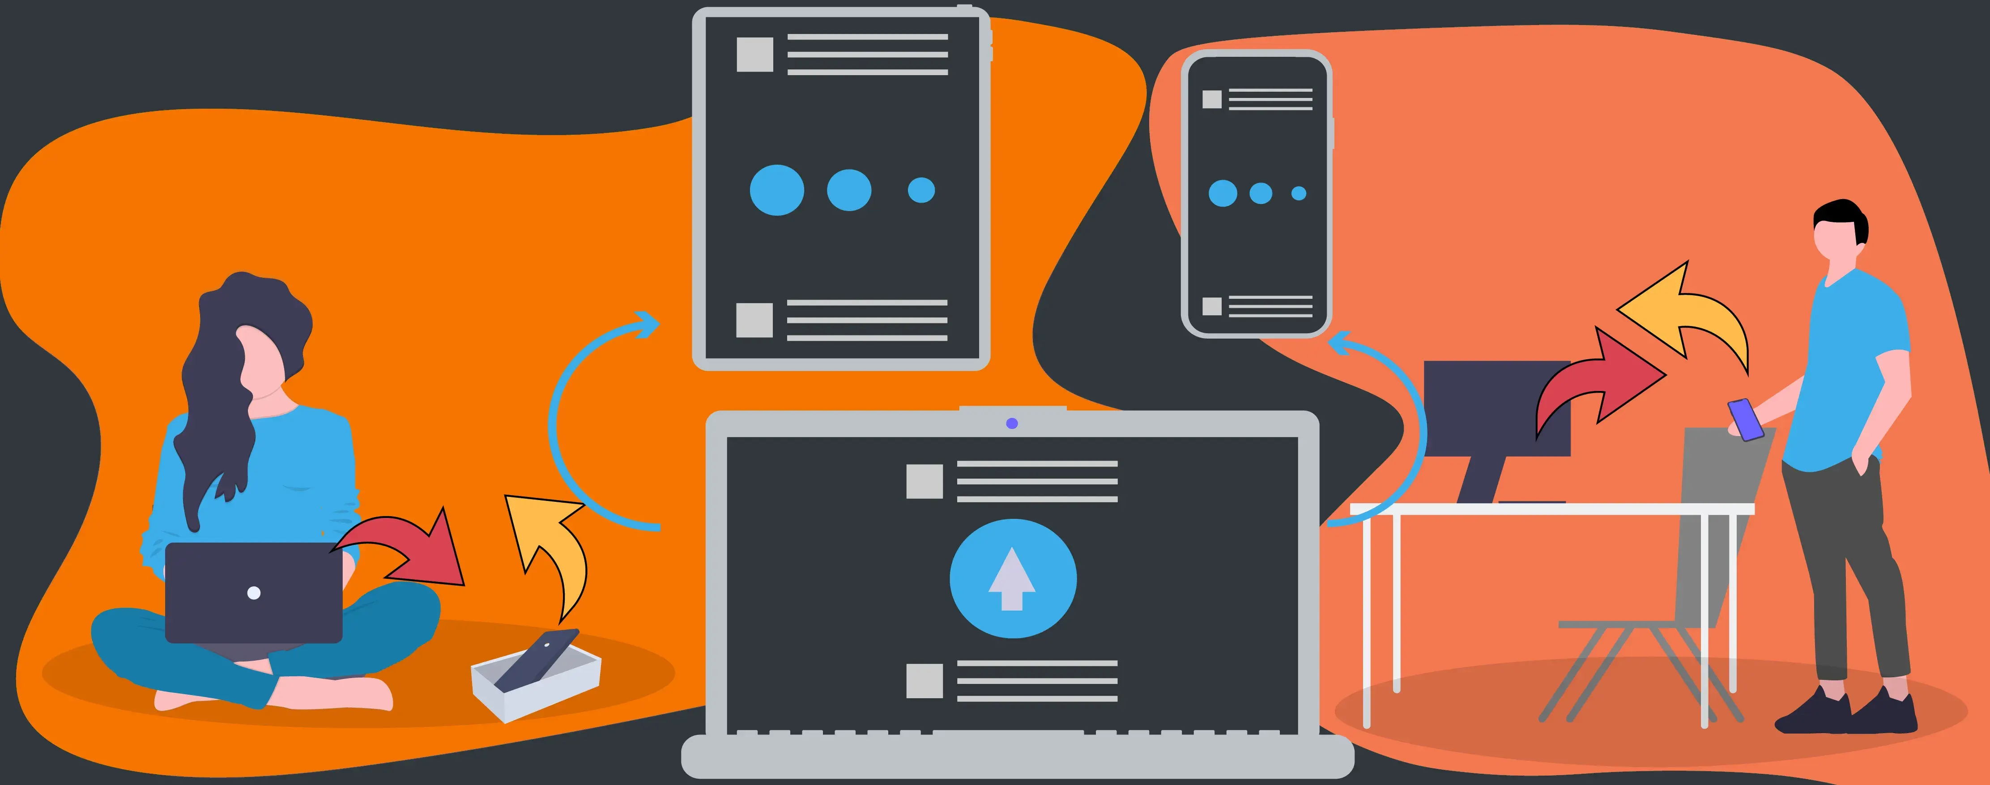
KDE Connect is a program for your Linux PC that connects to a companion app on your phone to integrate your devices. KDE Connect is available on every major Linux distribution and they say it works with all desktop environments.
Tip: GNOME users might prefer using GSConnect instead which is GNOME extension that re-implements the KDE Connect protocol for the GNOME Desktop.
Once you have it installed and running, all you need to do is pair the devices together and you can initiate this from either device.
KDE Connect is a project that enables all your devices to communicate with each other. Here’s a few things it can do:
- Receive your phone notifications on your desktop computer and reply to messages
- Control music playing on your desktop from your phone
- Use your phone as a remote control for your desktop
- Run predefined commands on your PC from connected devices
- Check your phone’s battery level from the desktop
- Ring your phone to help find it
- Share files and links between devices
- Browse your phone from your desktop
- Control the desktop’s volume using your phone
- Send SMS from your desktop

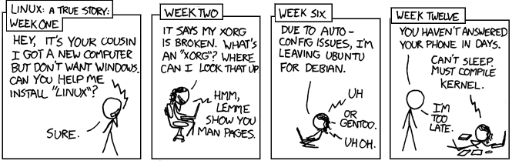
https://kdeconnect.kde.org/

https://xkcd.com/456/
Help us promote this month’s meeting, by putting this poster up on your workplace bulletin board or other suitable public message board:

https://muug.ca/meetings/MUUGmeeting.pdf
MUUG would like to thank Michael W. Lucas for donating one of his ebooks every month as a door prize. You can view and purchase his tech books here:

https://www.tiltedwindmillpress.com/product-category/tech/
Except where otherwise noted, all textual content is licensed under a Creative Commons Attribution-ShareAlike 4.0 International License.

https://creativecommons.org/licenses/by-sa/4.0/
A big thanks to Les.net for providing MUUG with free hosting and all that bandwidth! Les.net (1996) Inc. is a local provider of VoIP, Internet and Data Centre services. Contact sales@les.net by email, or +1 (204) 944-0009 by phone.
Beep When Another Box Finishes
by Trevor E Cordes
Did you know pulseaudio allows playing audio over a network? Have you ever wanted an event or process on another box (no matter where it’s located) to play a sound on your workstation? Wouldn’t that be great if you could be notified when something you’re waiting for occurs? Without having to rely on or check your email?
pulseaudio can do it, and it’s pretty easy. It’s much like you used to do to allow remote X clients to show windows on your local workstation: you need to copy over a cookie.
As the user on your workstation (not root), find the ~/.config/pulse/cookie file. Copy it to the same directory on the remote box, in the home directory of the user the remote program will run as (perhaps root).
Make sure your local workstation has TCP port 4713 open for pulseaudio connections. If you are natted you will need to setup a tunnel of some sort. You can use firewall rules to limit connections to only boxes you authorize (in addition to the cookie security).
To play a sound, have your remote event call:
paplay -s 192.168.1.1 /usr/share/sound/foo.wav
Where the IP address is the one of your local workstation. For some reason using hostnames wouldn’t work, so you may need to specify the actual IP.
The wav file you choose (many simple formats are supported) must exist on the calling box. I find game programs are the best source of cool and useful wav files for this purpose, so install some games and do a: find /usr -name “*wav”. Or copy some from your box.
Voila! Your server can now bug the heck out of you when important events occur, like the finishing of a long-running script.
You can also use this to have programs running as another user on the same box play sounds, for instance root. This can be useful for daemons to communicate with you. The steps for this are the same as the above.
GIMP 3.0 arrives after 7 years
Naturally, there are some big changes since 2018’s version 2.10.

A major update to GIMP (the GNU Image Manipulation Program) has arrived on March 17th. GIMP 3.0 has been finalized and released to relieve GIMP 2.10 from its duty as the premier free and open source image editing software for multiple platforms. Tom’s Hardware recently crowned GIMP the standard for free image editors in a comprehensive comparison article. Now with version 3.0 hitting mainstream, they claim it might become unassailable.
The release notes for GIMP 3.0 are extensive, but the highlights of the new release go beyond the UI, include the addition of features like the non-destructive layer effects, improved color management, bolstered file format support, and refined text support. Plus GIMP’s mascot, Wilber, also got a new lick of paint.
The goodies don’t stop there, as users will also see a multitude of usability improvements. Popular features such as Layers, Channels, and Paths have had developer attention, as have workflow concerns and shortcuts.

https://www.gimp.org/news/2025/03/16/gimp-3-0-released/
Nice PDF, But Can It Run Linux?
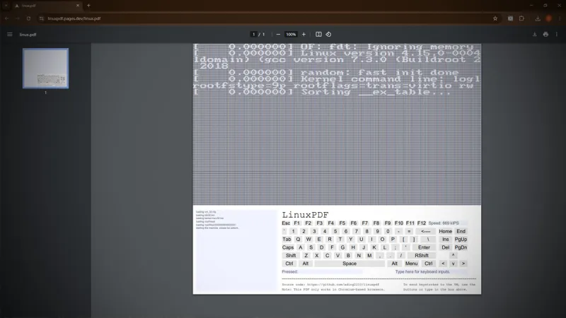
The days that PDFs were the granny-proof Swiss Army knives of document sharing are definitely over. According to [vk6], he has managed to pull off the ultimate mind-bender: running Linux inside a PDF file. Yep, you read that right. A full Linux distro chugging along in a virtual machine all encapsulated within a document. Just when you thought running DOOM was the epitome of it. Mind-boggling, or downright Pandora’s box?

https://hackaday.com/2025/02/10/nice-pdf-but-can-it-run-linux-yikes/
Fedora 40 Ditches DRPM
by Trevor E Cordes
The experiment is over. After many years and Fedora releases that allowed the use of Delta-RPMs, the team has decided it’s not worth the effort anymore.
Delta-RPMs allowed the Fedora repos to include rpms that contained only the differences between the rpm versions (the “delta”). In theory this would allow massively smaller filesizes. In practice, though, the savings reported by dnf/yum when using delta was often around 1% -- meaning useless.
With bandwidth so cheap and fast these days, it seems no one cared anymore. In addition, the complexity of the whole delta system was non-trivial for both the builder and repo manager.
Run Command Later With Output
by Trevor E Cordes
Have you ever wanted to run a command later, like you can do with the “at” command… but you wanted to see its output as it’s running in a terminal? And also have interactive control over that command?
Try this:
sleep 3600; command
Which will run “command” after one hour delay, in the terminal it’s typed into. This is ideal if command is something you normally want to watch or interact with, but do not want to start immediately.
Sure, you can do similar with “at” and output redirection, tail -f, and even wacky SIGSTOP kills; but sometimes the easy way is better.


